HONG KONG INSTITUTE OF VOCATIONAL EDUCATION
Tutorial 4: Goals and Conversion Name(s): ________________________
Class: ________________________

Module Intended Learning Outcome (#1&2):
On completion of the module, students are expected to be able to:
- Understand the web analytics industry and career, and the key concepts of web analytics;
- Understand web analytics for web optimization and the web analytics tools availability.

Lesson Intended Learning Outcome:
On completion of this lab, students are expected to be able to:
- Define objectives and goals for a website;
- Define a set of Key Performance Indicators to track goal achievement;
- Set up Goal Conversion in Google Analytics.

Task 1 – 4 will be done by group while Task 5 is Individual

TASK: Answer the following questions by referring to your report website:

- What is the purpose of the Company/Organization? (Group)
  - To promote the enthusiasm for sports, especially football, to others.

- What does the company/Organization want users to do on the website? (Group)
  - View news about sports
  - Review information of users’ favorite footballs team
  - Order sports souvenirs
  - Join sports activities
  - Allow users to create and login their accounts
  - Allow users to get their account back if they forget their account
- What are the Goals and Objectives of your website? (Group)
- Promote football to visitors
- Sell souvenir to the football lovers
- Let more people join with the football activities
- Provide and gather information about football to users

- What are the micro conversion and macro conversion activities? (Group)
  - Micro conversion
    - Create account
    - View an individual product page
  - Macro conversion
    - Making a purchase by asking the visitors to fill in order form to buy souvenirs
- Referring to the goals and conversions you specified in the above questions, set the conversion goal in Google Analytics. Your answer should specify the name of the Goal, how to track your goal and explain with screen caps of Google Analytics. (Individual – each group member responsible for one conversion goal)

  - As we would like to see if visits login their accounts on our website, we create an event which records whether users have visited our login page. Then, the records will be converted and shown in GA.
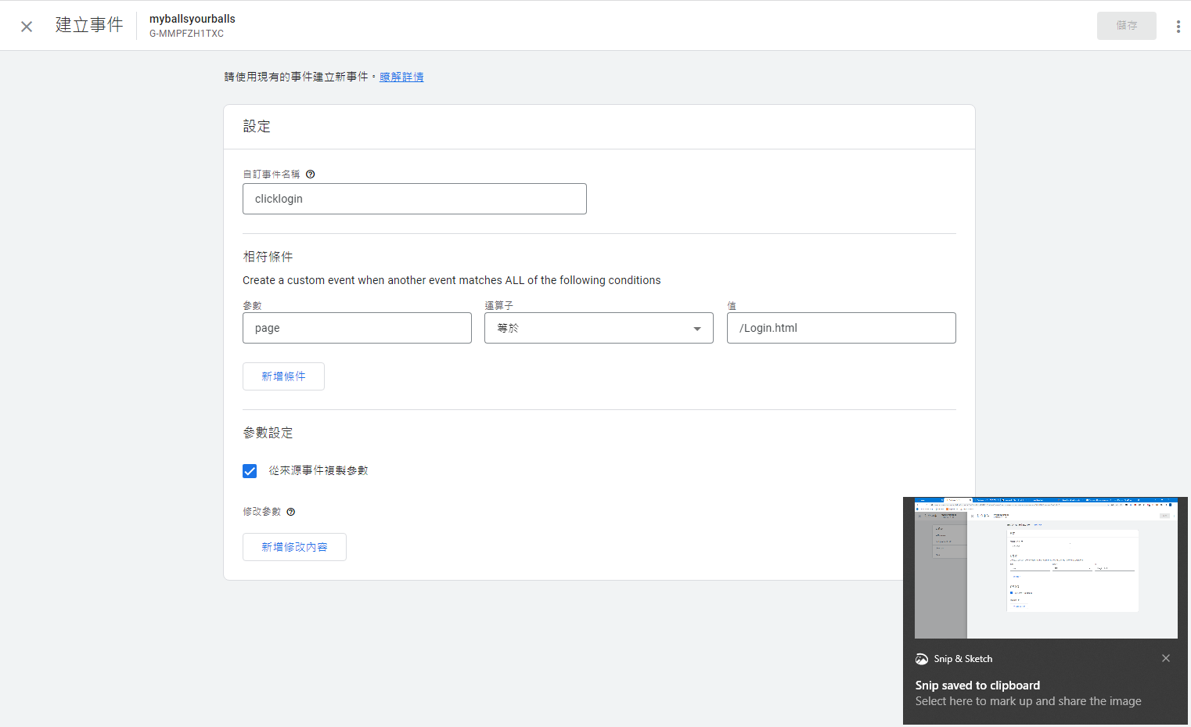

Deliverable:

Submit by group leader to Moodle. File name ITP4827_Tutorial4_YourName

